Restaurant Manager — Analytics Dashboard Journey
Project Overview
Project Title | Food Ordering Behaviour and Customer Trends
Repository | Food-Ordering-Analytics-Dashboard
Website | Flask web application with an embedded Tableau Dashboard and Tableau Story
Team Members | David Goyar (Team Lead) • Ravi Sharma • Kartik Gupta • Harsh Naruka
Project Description
The project analyzes approximately 50,000 food ordering records using Tableau Public. It delivers business insights through an interactive Tableau Dashboard and Tableau Story, both embedded in a Flask-based web application.
The dashboard covers the following areas:
- KPI Dashboard
- Cuisine Demand Analysis
- Revenue Analysis
- Customer Rating Analysis
- Delivery Time Analysis
- Meal Type Analysis
- Restaurant Segment Analysis
- Customer Age Group Analysis
- City-wise Order Analysis
- Interactive Filters
Its objective is to help restaurant owners, managers, and business analysts understand customer ordering behaviour and make informed business decisions.
Customer Persona
Primary User | Restaurant Manager
Age | 35–45 years
Occupation | Restaurant Manager
Experience | Manages day-to-day restaurant operations and overall business performance.
Goals
- Understand customer ordering behaviour.
- Monitor revenue and key performance indicators.
- Identify popular cuisines and demand patterns.
- Improve customer satisfaction.
- Optimize overall business performance.
- Make data-driven decisions.
Challenges
- Large volumes of raw operational data.
- Difficulty identifying business trends manually.
- Limited visibility into customer preferences.
- Time-consuming manual reporting.

CUSTOMER JOURNEY MAP
Dashboard Analytics Journey — Five Stages
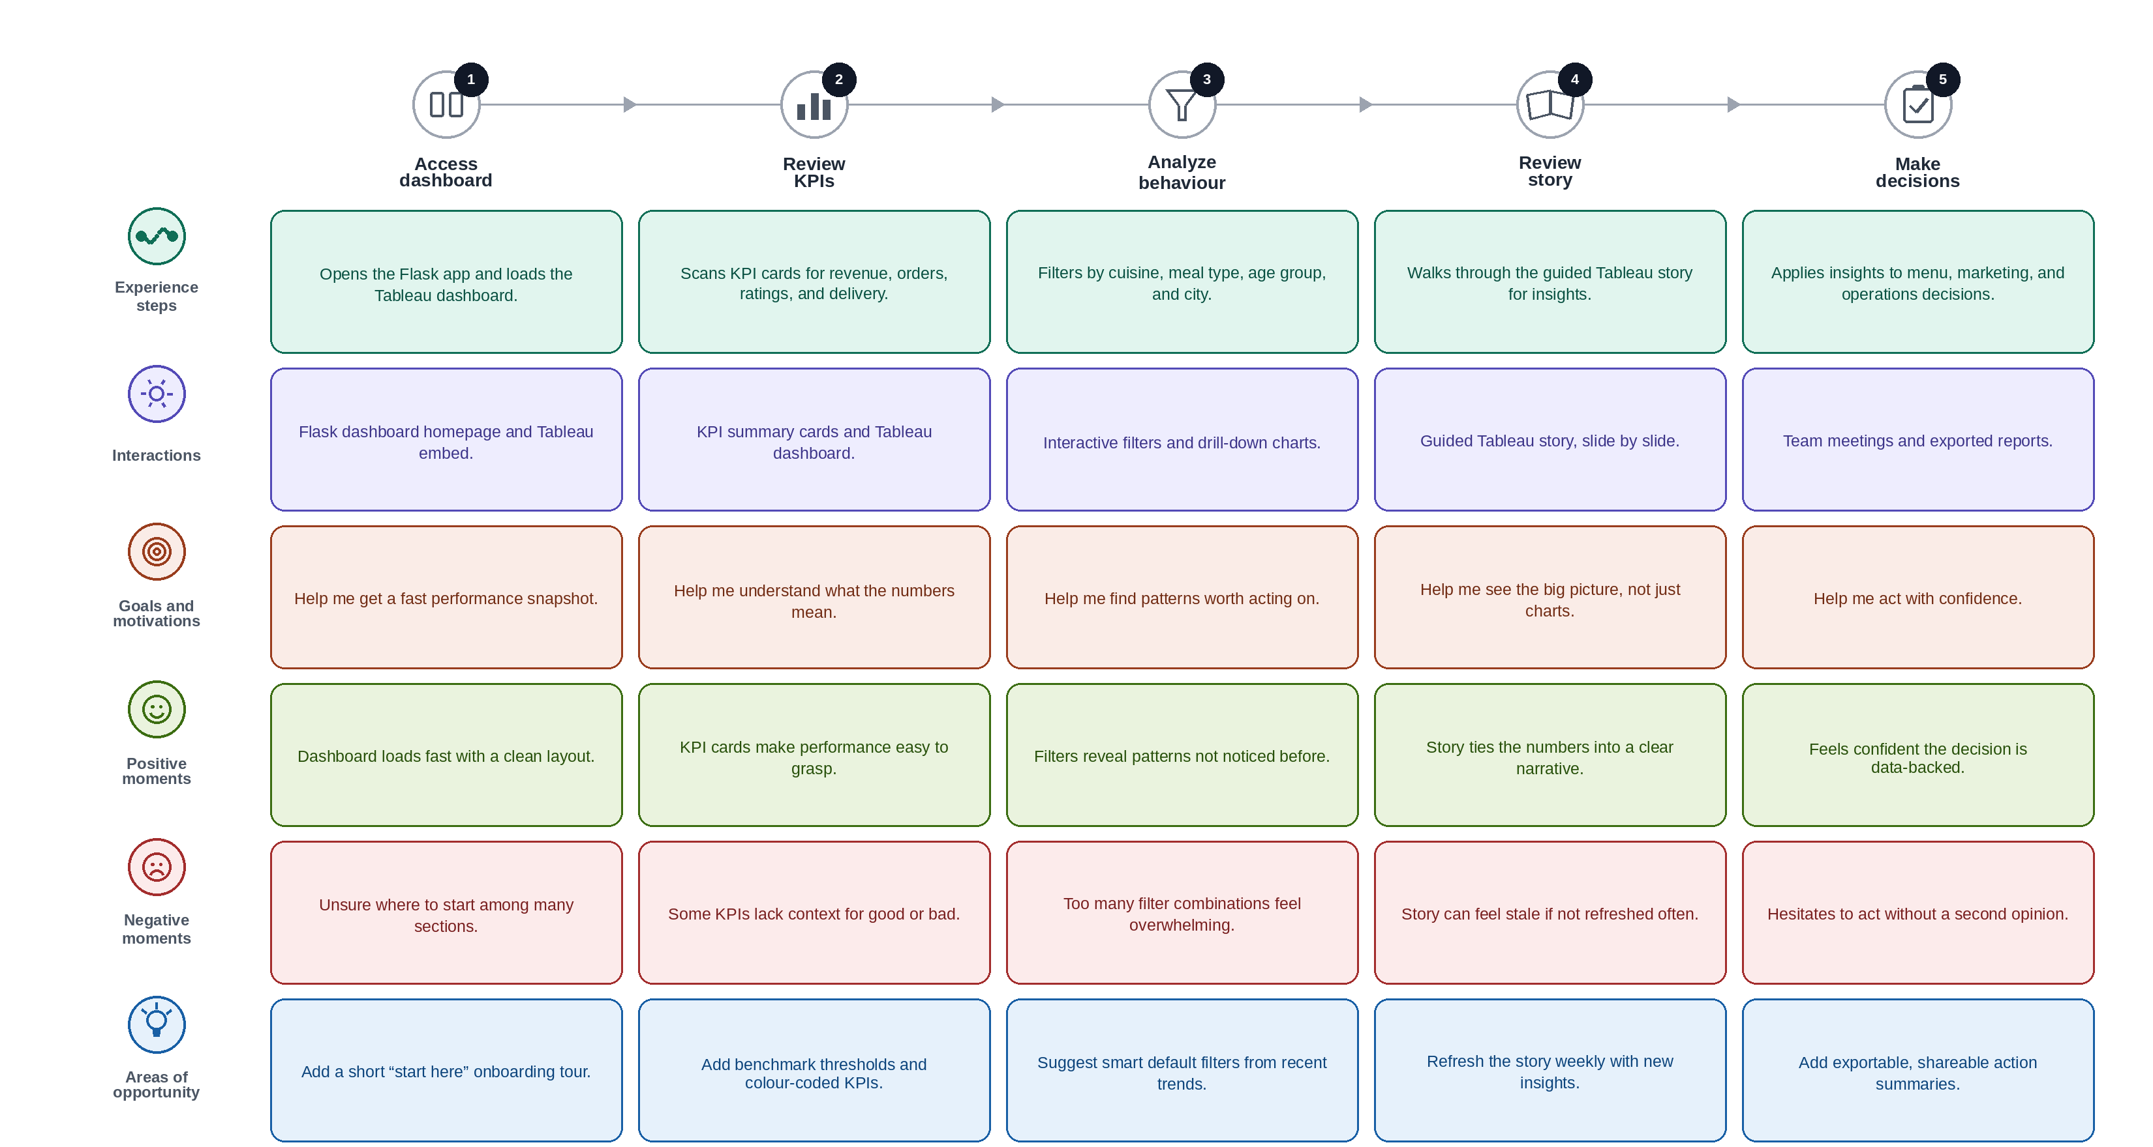
Prepared as part of the Food Ordering Behaviour and Customer Trends capstone project.

